**Possible** **Steps** **to** **complete** **your** **design.**

**1.** **Create** **an** **Attribute** **List** **(use** **this** **and** **extend** **as** **needed)**

|  |  |  |  |  |  |  |
| --- | --- | --- | --- | --- | --- | --- |
| Storage Type | Data type | Platform | O/S | Language | Architecture | Authentication |
| Local Server (MySQL or MSSQL) | Database | Mobile | Windows | C++ | Mobile | ID Number |
| Cloud Storage (Azure) | Xml file | Web based | Mac | Visual Basic | Thin Client | Email Address |
| Local Client (Access) | Text file | Desktop | Linux | Java | Rich Client | Cookies |
| None | Array | Web Server (Apache or IIS) | iOS | JavaScript | Peer to Peer | Renew each time |
|  | No SQL (SQL Lite) |  | Android | PHP | Internet Web App | Login |
|  |  |  | Windows Phone | Python | VPN |  |
|  |  |  |  | C# | Client/Server |  |
|  |  |  |  | HTML5 |  |  |
|  |  |  |  | JQuery Mobile |  |  |

**2.** **Select** **your** **preferred** **design** **options** **from** **the** **list** **for** **2** **to** **3** **options.**

**Option** **1**

All data sources will be stored on the local client, the original source will be in Excel or csv format. The application will be a rich client run upon a Windows desktop. The solution will be written in Visual Studio and will not require authentication as the Windows authentication to the desktop will secure the data. Data output will be in XML format.

**Option** **2**

All data sources will be stored on a local database through a client/server arrangement. Original source files will be in Excel or CSV format. The application will be web based on an IIS Server with the resultant data being stored in a MSSQL database. As this is a web based application it will run within a browser and be accessible through any OS. It will require a login to access the program. The web application will be written in PHP.

**3.** **Create** **approximately** **5** **or** **more** **evaluation** **criteria** **for** **your** **design.** **Consider** **you** **functional** **and** **non-functional** **requirements** **when** **setting** **your** **criteria.**

Create a table to house your criteria and set a scale between 1 to 5 to rate their performance

**Option** **1**.

|  |  |  |  |  |  |
| --- | --- | --- | --- | --- | --- |
| Criteria | Rating – 1 to 5 | | | | |
| Ease of Use: Is the interface intuitive and simple to use? |  |  |  |  |  |
| Speed of Processing: Is the loading of the file to its migration state quick to organise? |  |  |  |  |  |
| Relevance: Does the data types from the source file assist with the transfer of data? |  |  |  |  |  |
| Clarity: Is the migrated data easy to read and validate? |  |  |  |  |  |
| Completeness: Is all the relevant data visible on the one screen. |  |  |  |  |  |

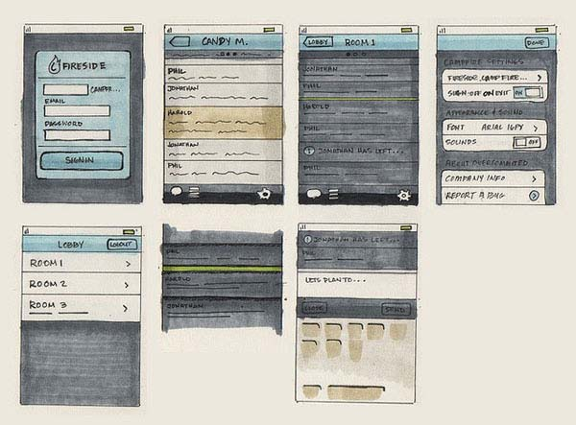**4.** **Draw** **2** **or** **3** **Mock** **up** **diagrams** **to** **support** **your** **options** **above**

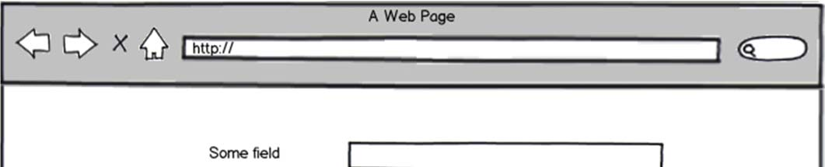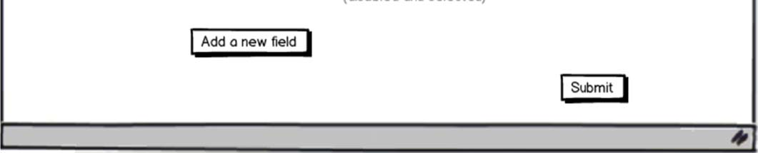

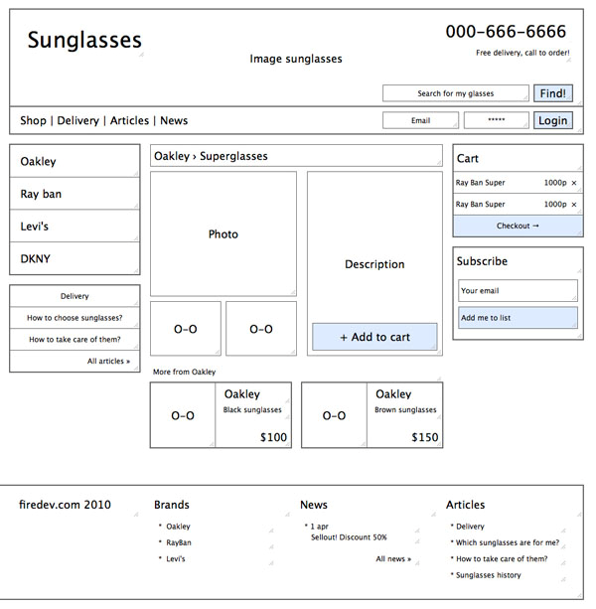

**5.** **Select** **the** **most** **appropriate** **design** **you** **will** **use** **for** **your** **solution** **and** **explain** **why.**

For my solution I will be using Option 1. Although Option 2 provides a much simpler interface and would meet the non-functional requirement of ease of use, the lack of relevant information from the source file and the necessary feedback to the user to provide a complete display of the entire process means it lacks too many of the clients requirements. By providing a display of each record being migrated I am able to ensure that the clarity of the data process is highlighted. The source selection in option 1 calls a dialog box for file selection and enables it to filter to xls and csv files. A familiar menu system adds to the ease of use as does the buttons to link the files to migrate to the destination fields. As the speed of processing is an important feature Option 1 enables all data to be visible on one screen to the process of migrating data and the feedback of the process is fully visible and enables feedback to the user prior to the process starting.

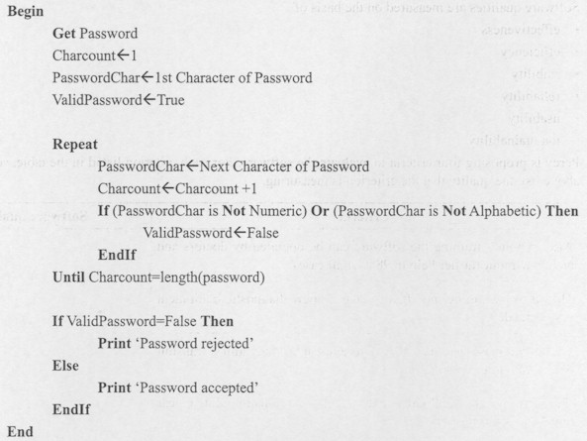**6.** **For** **your** **selected** **solution** **create** **any** **pseudocode** **for** **relevant** **algorithms** **in** **your** **solution.**

**7.** **For** **your** **selected** **solution** **create** **a** **data** **dictionary** **using** **the** **template** **provided.**

Data Dictionary Table

Table Name: tbl_Clients

|  |  |  |  |  |  |  |  |
| --- | --- | --- | --- | --- | --- | --- | --- |
| **Field** **Name** | **Data** **Type** | **Description** | **Default** **Value** | **Required** | **Validation** **Rule** **(if** **applicable)** | **Field** **Size** **(text** **field)** | **Key** **Type** |
| Client_ID | Integer | Client ID | Auto | Yes |  |  | PK |
| Client_Surname | String | Client Surname |  | Yes |  | 30 |  |
| Client_FirstName | String | Client First name |  | Yes |  | 30 |  |
| Client_DOB | Date | DOB |  | No | > 06/01/1964 |  |  |
| Client_Active | Boolean | Currently active member | Yes | Yes |  |  |  |
| Client_Add_ID | Integer | Link to Address table |  | No |  |  | FK |